FITTING INSTRUCTIONS FOR FIAT 500 – PANDA STEERING WHEEL SPACER
Warnings:
- Even if doing the installation with the battery still connected does not make the airbag warning light turn on (supposing the airbag module being properly re-connected at the end), do the whole procedure disconnecting the battery first.
- There is no need to park the car with the straight wheels before installation, because the spline has 3 non symmetrical markers (made as extra wide teeth) that allow the coupling in one way only. You can do the installation starting with the steering wheel in any position. Of course, keeping it straight it’s a good start.
- There is no need to extend any wire inside the steering wheel, they came long enough from the factory, both in manual and automatic gearbox cars. BUT, be carefull while handling the harness: never pull it, and pay attention about no pulling it accidentaly, you can damage the steering angle sensor, or hear an annoying “click” while rotating the steering wheel at the end of the job, which requires to re-do the whole procedure only for pushing back the wires towards the steering angle sensor.
- Although the spline of the cars has the same design across model years, it has happened on some cars that the clearance of the spline is much more tight between the steering wheel and the steel part of the spacer. This could make the steering wheel hard to push on the provided male splined shaft. To win this force, push the steering wheel by hand until it engages the spline for the first 1-2 mm, and when it starts to be hard, tight the central big nut. It’s tightening force will make the steering wheel slide on the shaft turn by turn. BE SURE THAT THE SPLINE IS WELL ALIGNED, IF NOT, THE STEEL SPLINE MAY RUIN THE STEERING WHEEL ALUMINUM FEMALE SPLINE, DAMAGING THE STEERING WHEEL AND MAKING IT VERY HARD TO PULL OUT. Another damage that may result from wrong alignment is that the nut will engage the thread slantwise, damaging the thread and making it nearly impossible to uncrew the nut and pulling out the steering wheel.
To avoid all this, is VERY USEFUL to pre-fit the steel male splined shaft provided on the steering wheel doing the procedure on a bench/table. This will make easier to ensure the correct coupling on a more comfortable working place, where it would be easier to pull out the shaft in case of accidental damage.
I repeat this pre-fit procedure step by step:
- After the steering wheel is out from the car, take the steel male splined shaft part of the steering wheel spacer, lay the steering wheel upside down on a table (the crown of the steering wheel must touch the surface of the table) and push it by hand in the steering wheel, and the steel shaft must be pressed from the back side of the steering wheel, now upside, keeping care that the 3 markers are perfectly aligned. There is only 1 alignment possible because marks are asymmetrical, and the spacer can be fitted only from the back of the steering wheel. Do not attempt to fit the shaft from the front (airbag) side.
- Check that the steel splined shaft is straight inside the steering wheel central hole, pull it out and repeat if you have the most little doubt it’s oblique.
- When you’re sure that the splines are aligned, pre-push the steel shaft inside the hole. A single soft hit with a rubber hammer helps.
- Put the washer and screw the nut on the male splined shaft, by hand, until it stops.
- Tight the steel splined shaft on a bench vise
- Tight the nut using a wrench until it stops.
- Pull out the assembly from the bench vise.
- Pull out the steel shaft by untightening the nut and hammering out the shaft itself USING A RUBBER HAMMER OR ANOTHER SOFT TOOL, in any case, whatever you use, KEEP CARE NOT HITTING THE THREAD.
- At this point the coupling between steel and aluminum is adjusted, and it will be easier to fit the steering wheel on the steering wheel spacer while doing it on the car.

INSTALLATION PROCEDURE
There are many tutorials on the internet / youtube, I resume here the steps required, but it’s much easier after looking a video.
- Remove the 2 plastic shrouds that covers the stalks/wipers lever assembly. Start unscrewing 2 cross head screws (they may be torx in some cars) that are upside down and lock the bottom shroud in position. Then unlock the mating coupling between the 2 shrouds (it can be very hard, you need both force and sharp attention) and remove the bottom side shroud. The top side shroud is fixed thanks to 2 screws (same as the other 2) which are upside down hidden between the shroud itself and the clockspring assembly.
- Pull out the airbag unit from the steering wheel. Unlock the 3 clamp springs inserting a flat screwdriver in the 3 holes at the rear of the steering wheel (3,6 and 9 o clock position). Use a total 10 cm (4”) long flat screwdriver, 2-3 mm wide and keep care not scratching your dashboard with the back handle of the screwdriver.
When the airbag unit is in your hands, unplug the sockets in the back of it. The 2 sockets that actuate the airbag must not be pulled because they have a kind of trick: a radial plastic clip must be pressed to unlock the sockets. All other sockets are one-way and there is no possibility to make mistakes while re-connecting.
Lay the airbag unit far from working area, you can hold it on the back seat temporarely.
- Unlock the central nut, without removing it yet: the steering wheel can be hard to pull out in some case, and sudden unlock may result in hurt yourself by throwing the steering wheel on your teeth, also, pulling it out too fast may damage the pending harnesses.
- When you’re sure the steering wheel is easy to came out, remove the nut and stock both nut and steering wheel somewhere, for example, the passenger seat.
- At this point, fit the aluminum side of the steering wheel spacer on the steering column. There is only one way to do it, you cannot insert it in the wrong orientation because there is only 1 orientation possible. You don’t need to force it, it will slide in quite easily but without play.
The harnesses on the clockspring assembly should come out from the single big bore just above the flat slot. See picture below.

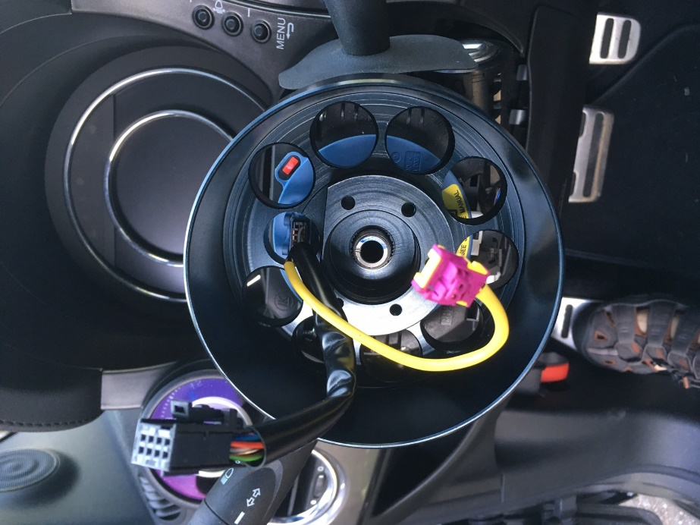
Use the provided nut and washer to tight the aluminum hub on the steering column.
- Check that the clearance between the steel male splined hub and the steering wheel is not too tight, in case you’re not able to push it inside by hand, adjust the clearance following the procedure at point 4 of the Warnings.
- Fit the steel male splined hub on its corresponding aluminum hub, tightening the 5 bolts provided. You better use Loctite while tightening the bolts.
- From now on, fit the steering wheel back in place. Fitting is the opposite of removal. The only difference is that you’re going to insert the steering wheel on the extended shaft, instead of the steering column. The harnesses must go through the central square slot, in line with the bore in the steering wheel spacer. Again, keep care about not pulling the harness while handling it, and be sure it has slide back through the hole, avoiding it to be stretched.
Keep care when you re-push the airbag unit in place: look that it is well aligned and it’s not going to press the wires, otherwise you can hear your horn permanently when switching ignition on.
There is only one way to push the airbag unit back in place, and you will hear a reassuring “clunk” if it is done properly. Again, have a look on youtube tutorials about steering wheel installation.
- Reconnect the battery.
END.

