INSTRUCTIONS FOR PORSCHE 997 987 991 981 STEERING WHEEL SPACER
VALID FOR AUDI VW SKODA SEAT 2000 ONWARDS
Warnings:
- If you have electric seat, make it slide all backward, so you will gain some more room while fitting the steering wheel spacer. Do this before disconnecting the battery.
- Do the whole procedure disconnecting the battery first, to avoid airbag warning lights switch on after the assembling.
- Porsche spline is made of many little teeth, and there isn’t any kind of mark or thicker tooth to maintain a unique orientation of the steering wheel while sliding it inside the column. This make very easy missing a tooth or two while re-fitting the steering wheel on the column, and the spacer too. This will result in your steering wheel turned a little bit off-centre while driving on a straight line. Park your car with straight wheels before following the entire procedure, and let a friend hold the steering wheel while unscrewing the main centre bolt. This will help maintaining the correct position.
- Handle the OEM harness with care, especially while (un)connecting the plugs. You can use a pair of little nippers to make wires connect each other because your fingers will be too big. The harness is made to make easier the whole fitting procedure. If you have time, tools and a lot of patience you can extend the wires inside the steering wheel and avoid the need of the harness, relocating the big connector 2-3” further.
EXTRACTING THE STEERING WHEEL : There are many tutorials on the internet / youtube, I resume here the steps required, but it’s much easier after looking a video.
- Pull out the airbag unit from the steering wheel. Unlock the 2 clamp springs inserting a flat screwdriver in the 2 holes at the sides of the steering wheel. Grinding a bit the screwdriver in the middle of the flatness point, making a kind of “C” will help you finding the clamp springs.
- You don’t need to fully separate the airbag unit from the harness. You can hold it with the 2 yellow sockets still in and just disconnect the big connector that reach all steering wheel wires and join them to the steering angle sensor. If you wish to separate the airbag unit you have to disconnect the plugs from the back side of the airbag, after lifting the orange secure clips, using a little flat screwdrivers. The orange clips needs to be lifted just a pair of millimeters, but they will still be in place, together with the yellow plugs.

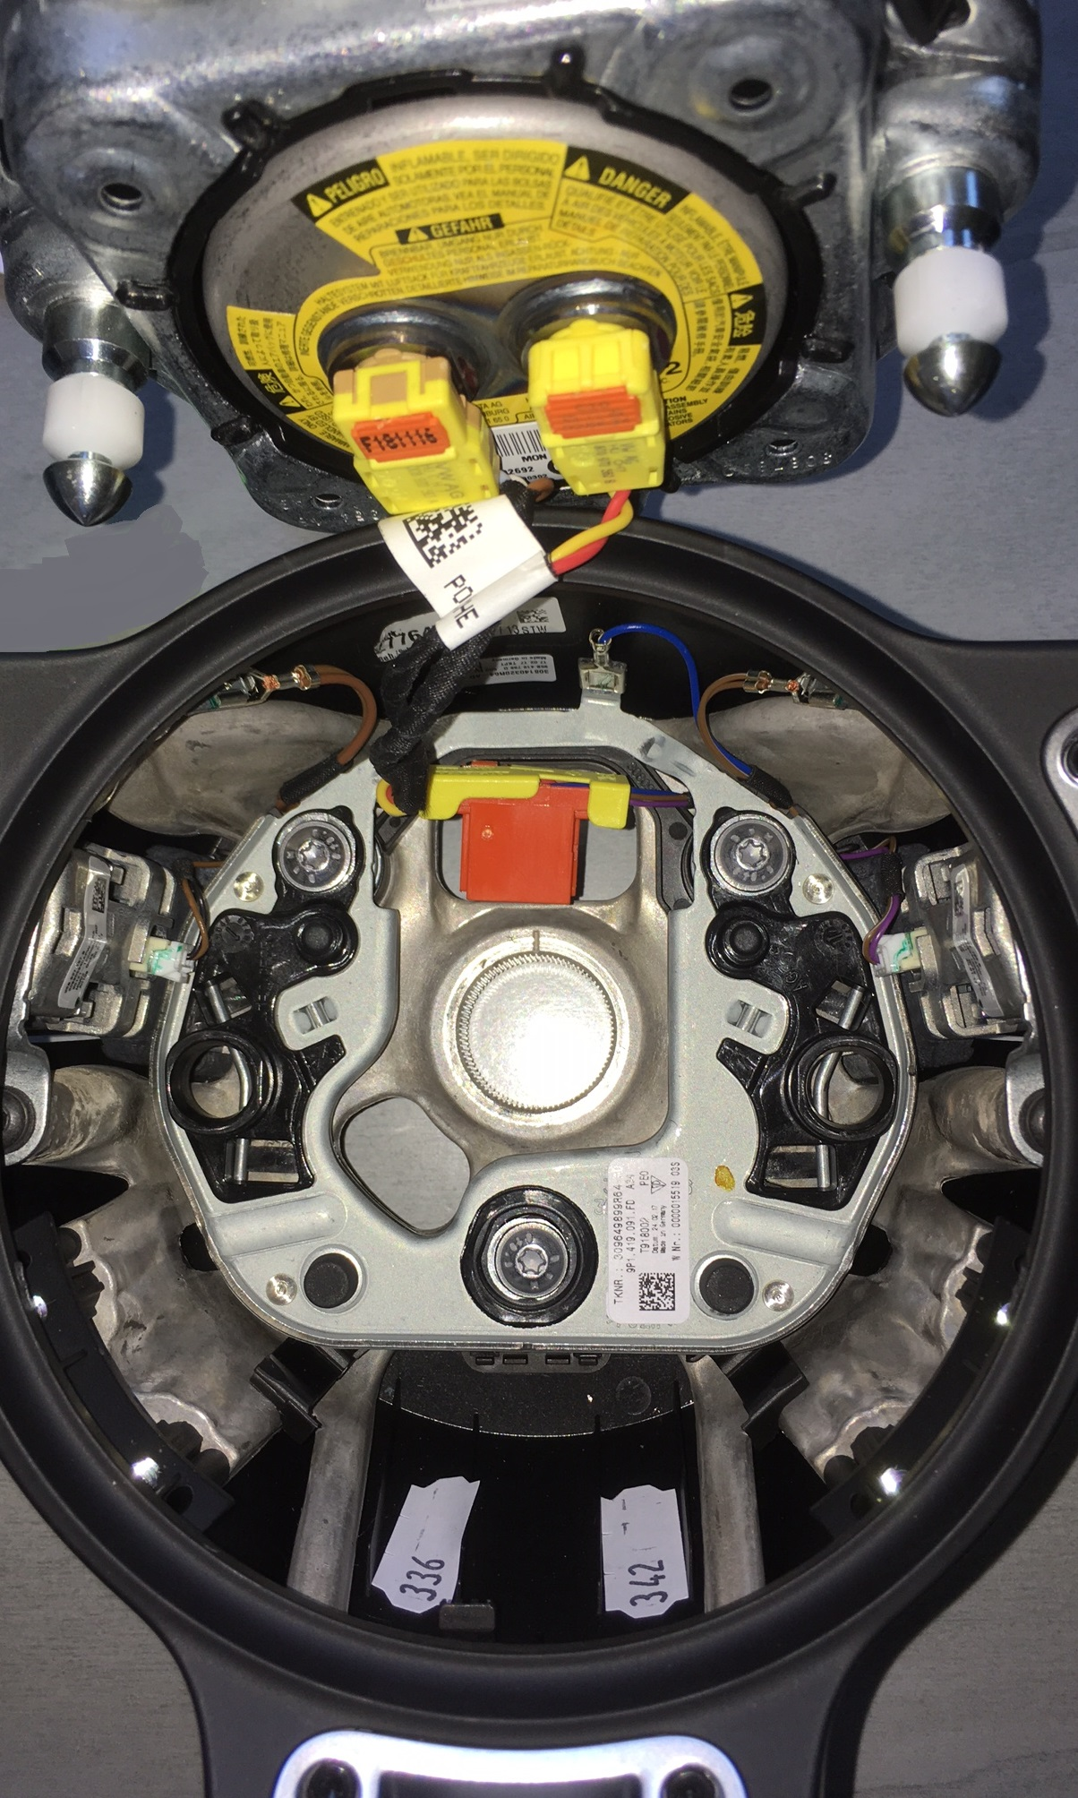

- After disconnecting the main connector which seats in the rectangular slot just above the central big screw, uncrew it. While doing it, let another person holding the steering wheel in its straight position. This will help maintaining the steering wheel straight, and divide by two the effort of unscrewing.

- At this point, the steering wheel will come out easily, if it’s a bit hard, you can pull it. Leave the main screw in the steering column while pulling (unlocked, but still screwed in just for a few turns), so if the steering wheel will unlock suddenly from its position, it won’t hit your face.

- This is what you will see at this point, it may be slightly different between other cars of the VAG-Porsche group (black instead of glass, less sockets).

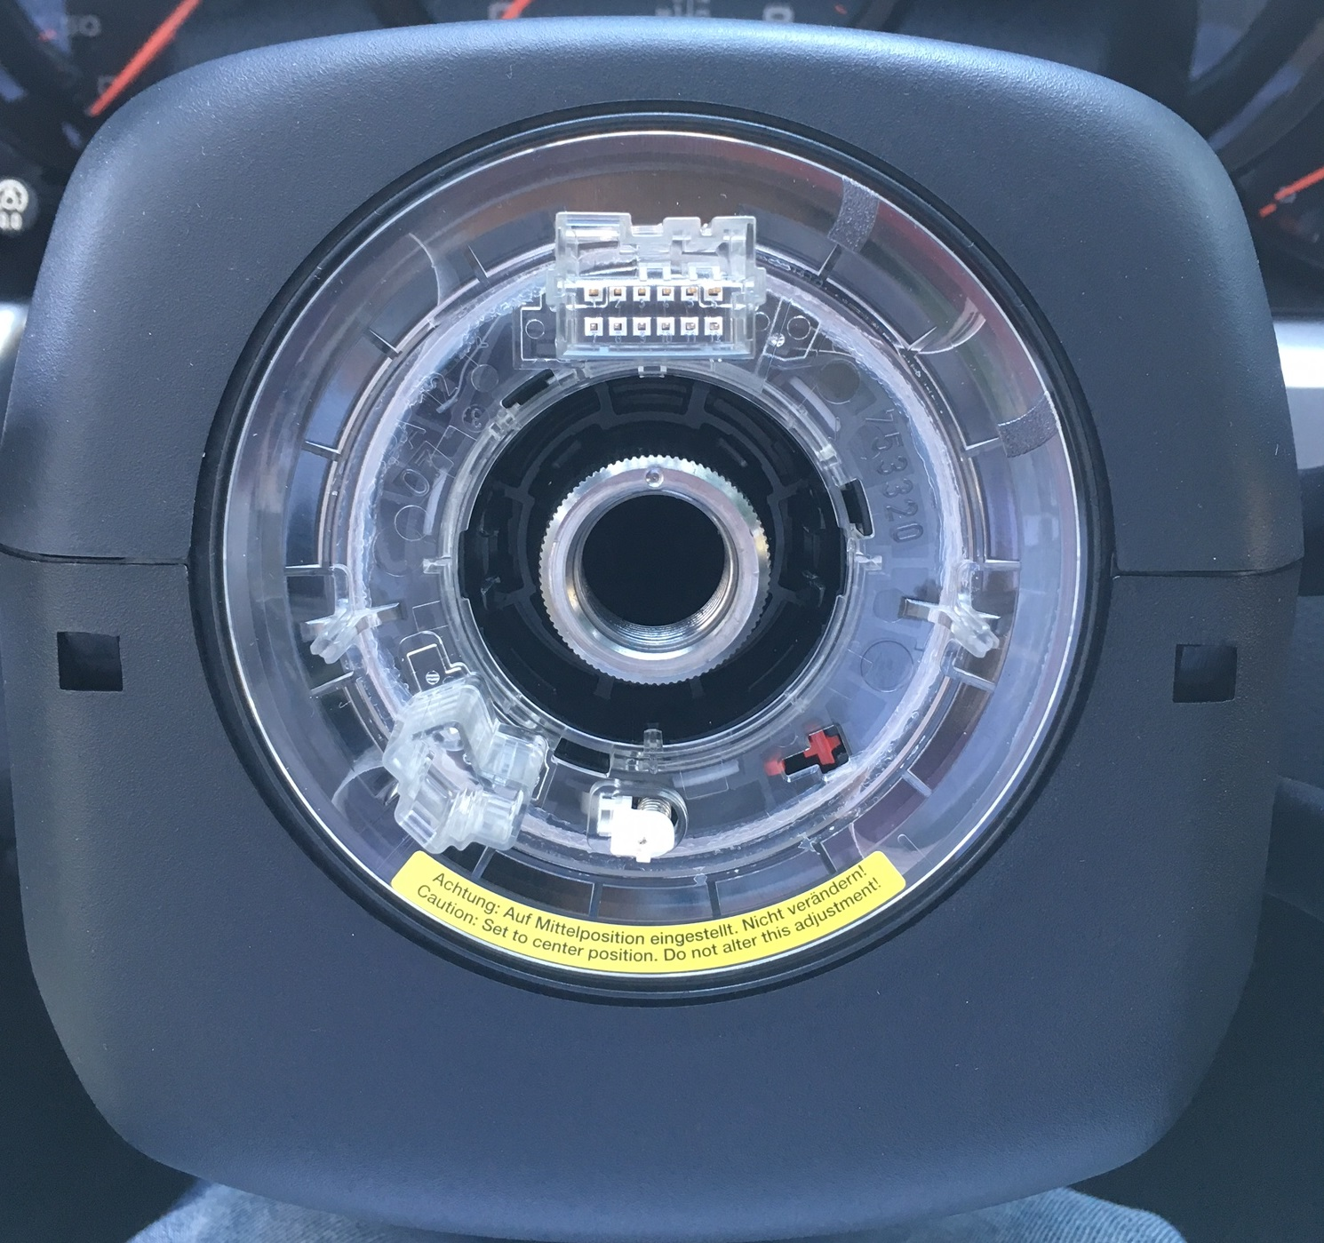

The OEM harness is made by 12 wires gathered in a 6 + 6 pin connector. The provided harness is made by 2 (4) black 6 pin (or 3 pin) harnesses.
Make the female pins of the provided harnesses slide in the steering wheel angle
sensor slot. A nipper will help. Connect in line the other 2 harnesses.
- Fit the female splined spacer in the steering column. The back side of it has the slots exactly as in the steering wheel. The black wires must cross the spacer through the big rectangular slot.
- Tight the OEM big M18 Torx bolt to hold the female spacer on the steering column.
- Insert the steel side of the spacer in the aluminium female splined spacer, and tight the 7 bolts.
- Fit the steering wheel in the male side of the steering wheel spacer. In while, connect the 12 pin OEM connector to the 2 harnesses. Another person holding the steering wheel in while will help a lot, unless you have 3 hands.
- Lock the provided M18 bolt, interchangeable with the OEM. At this point the steering wheel is fitted back in place.
- Reconnect the airbag to the plugs if you have unplugged it, and push it in the steering wheel housing. There is only one way for the airbag to sit in place, and you will hear a reassuring “click” when it’s in place. Make sure not to press any wire, otherwise your horn may sound permanently.
- Reconnect the battery.
END.

