FIT TING INSTRUCTIONS FOR MAZDA MX5 RX8 STEERING WHEEL SPACER
Warnings:
- Park the car with the straight wheels before installation, because the spline does not have any marker (made as extra wide teeth like other car brands) that allow the coupling in one way only.
- Disconnect the battery before installation. This will avoid warning lights on after the procedure.
- Be carefull while handling the harness: never pull it, and pay attention about no pulling it accidentaly, you can damage the steering angle sensor, or hear an annoying “click” while rotating the steering wheel at the end of the job, which requires to re-do the whole procedure only for pushing back the wires towards the steering angle sensor.
INSTALLATION PROCEDURE - There are many tutorials on the internet / youtube, about how to remove the airbag and the steering wheel, I resume here the steps required, but it’s much easier after looking a video.
- Pull out the airbag unit from the steering wheel: uncrew the 2 torx bolts at each side of the steering wheel, behind the horizontal spokes. When the airbag unit is in your hands, unplug the sockets in the back of it. Don’t pull them out with force, they all have a secure plastic clips, unlock them first.
- Lay the airbag unit far from working area and children.
- Unlock the central nut, without removing it yet: the steering wheel can be hard to pull out in some case, and sudden unlock may result in hurt yourself by throwing the steering wheel on your teeth, also, pulling it out too fast may damage the pending harnesses. An extractor may be necessary. It fits in the 2 M8 holes close to the central nut and with a central screw you will be able to unlock the steering wheel from the column.
- When you’re sure the steering wheel is easy to came out, remove the nut and store both nut and steering wheel somewhere, for example, the passenger seat.
- Now you can see the steering angle sensor, this is the moment to extend the wires if required. Depending on the model year, the harness can be detachable from both steering angle sensor and steering wheel side, or only from 1 of its ends.
Also, it may be possible that airbag wires can’t be disconnected from the steering angle sensor (either clockspring assembly), while the steering wheel button harness remains attached at the steering wheel. Airbag wires are usually longer than other wires and may never require extension. About steering buttons’ harness, the solution to avoid the cutting and extension of the wires is make the harness run across another way inside the steering wheel, gaining some centimeters.

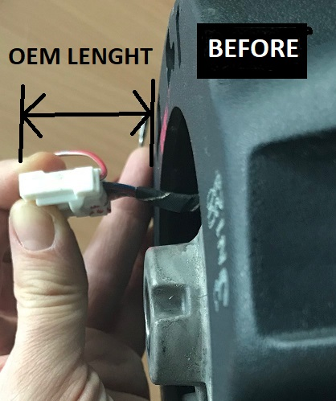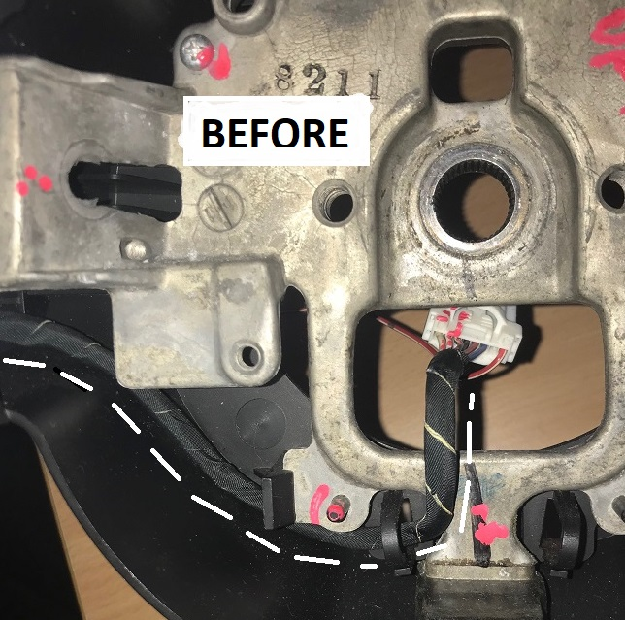

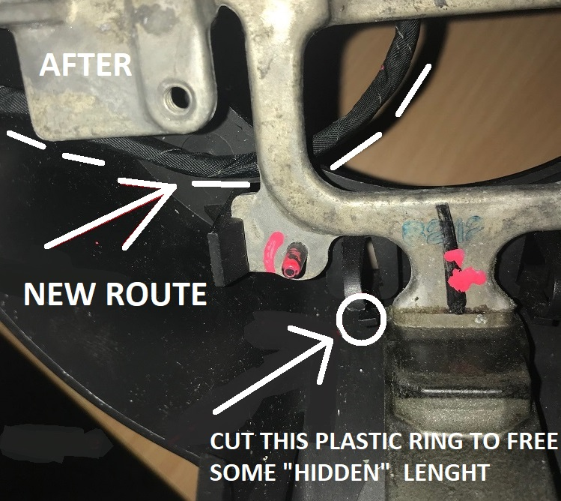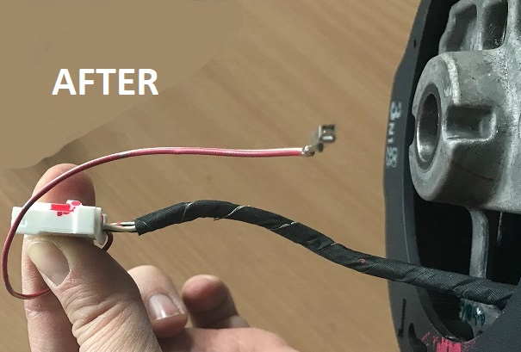

- Fit the aluminum side of the steering wheel spacer on the steering column, keeping the orientation of the slots horizontal. Tight the central OEM nut what was holding the steering wheel on the column.The harness must go across the slot in the spacer.
- Fit the male splined steel side of the spacer on the aluminium side, tightening the bolts. Use Loctite.
- Fit the steering wheel back in place. Fitting is the opposite of removal. The only difference is that you’re going to insert the steering wheel on the extended shaft, instead of the steering column. The harnesses must go through the central square slot, in line with the corresponding slot in the steering wheel spacer.
Keep care when you re-push the airbag unit in place: look that it is well aligned and it’s not going to press the wires, otherwise you can hear your horn permanently when switching ignition on.
There is only one way to push the airbag unit back in place. Again, have a look on youtube tutorials about steering wheel installation.
- Reconnect the battery. END.

